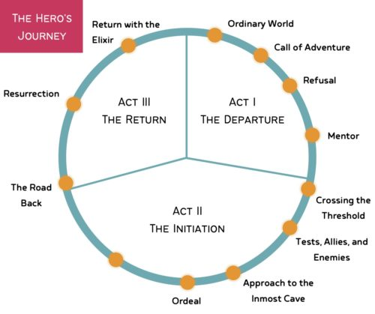

Why is it in a circle? Because the hero leaves their [includes any gender or number], Ordinary World only to return in the end. That’s a defining feature of the Hero’s Journey. The protagonist [hero] always comes back to share the benefits of their victory. Now to answer the question: What is the Hero’s Journey? What actually happens?

Act One: The Departure

. The Ordinary World
This is where we get to know the protagonist and understand what “normal” is to them. We also get a glimpse of the skills, beliefs, and priorities that guide our hero’s day-to-day life before the adventure changes them. If I meet Katniss Everdeen when she’s hunting with her best friend to provide for the family she values deeply. I’ve got a friend. I’d do anything for my family. I get her whole deal now.

2. The Call of Adventure
This is where the hero is forced out of their comfort zone. It could be that the protagonist has made an intentional step towards adventure, like Katniss volunteering as tribute. Or they are summoned, like when Harry Potter is called to his first year at Hogwarts. The Call of Adventure can even be accidental. This moment clarifies the hero’s goal, sets the stakes high, and establishes a challenge that ultimately cannot be ignored…...even though the protagonist will try to ignore it.

3. Refusal of the Call
The hero responds to the challenge with a “No thanks!” This can be a direct refusal or it can just be a feeling of resistance, like Jonas’ apprehension as he approaches the Ceremony of Twelve in The Giver.

4. Meeting the Mentor
Here hero meets the person who will prepare them for the adventure. The mentor relationship can take many forms. This character might literally train the hero in the skills needed to get through their adventure victoriously. Or the mentor might simply provide wisdom, motivation, tough love, or a hot new look if you’re Cinderella. Either way, this character provides whatever the hero needs to stop ignoring the Call and finally Cross the Threshold.
Act Two: The Initiation
5. Crossing the First Threshold
The protagonist is in it now. They’re ready. They’re committed. And they are charging beyond the world they know into a reality full of challenges they do not understand. This beat launches the central conflict of story and plunges the protagonist into the challenges that will define their character arc. Pro tip for holding readers attention: make it clear that there is no turning back. The Hunger Games have begun. The arena is sealed. This is happening.

6. Tests, Allies, Enemies
In terms of page count, this is the longest of all twelve beats. In step six, the hero learns and adapts to the rules of their new world. They learn from both the friends and the enemies they pick up along the way. They also face unfamiliar challenges. This is where they pay off the promise of the premise.

7. Approach to the Inmost Cave
Now the hero is getting super close to reaching their goal. But first, they have to go through the Inmost Cave. So what is the Inmost Cave? It’s the most treacherous place in hero’s new reality. This could be a physical space, like the Chamber of Secrets. Or it could be a mental space or experience, like when Starr testifies before a grand jury in The Hate U Give. It’s important to note that step seven does not actually take place in the Inmost Cave. This is merely the approach. The tension builds

8. The Ordeal
Okay, now we’re in the Inmost Cave, and the hero is up against the biggest, most soul-defining challenge of their life. They are about to confront their greatest fear. In this step, the hero sees rock bottom. Against all odds, the hero overcomes. And they will never be the same again.

9. Reward
Because of all that heroism in the Ordeal, the protagonist now has the reward they sought. Things are looking up. They are feeling safer and looking forward to the future again. But hold on to; there will be a consequence for the hero getting what they want.
Act Three: The Return

10. The Road Back
The victorious hero is journeying back toward the top of the circle, back toward their Ordinary World. But the road home is longer than they remembered, and there are more obstacles than they anticipated. These obstacles are the consequence of the victory. For example, Katniss manages to get out of the arena 1) alive and 2) without having to kill Peeta, but the stunt she pulled to make it happen looked like an act of rebellion to the Capitol. To protect herself and her family, she now has to act super in love with Peeta.

11. Resurrection
This is the final test for the hero… one last challenge they must face before they can return home. This last challenge is the one that proves they’ve learned the lesson of the Ordeal. This is Harry’s sacrifice near the end of Deathly Hallows. It’s Lara Jean writing to Peter at the end of To All the Boys I’ve Loved Before. It’s transformation put into action.

12. Return with the Elixir
The elixir is whatever it is the hero has won. It may not be the goal they sought when the story began [emphasis added]. Many of the best stories involve a protagonist who discovers that what they actually needed was not what they thought they needed. Either way, the hero returns victorious, and we understand that their world will now be different because they’ve been tested and won.

