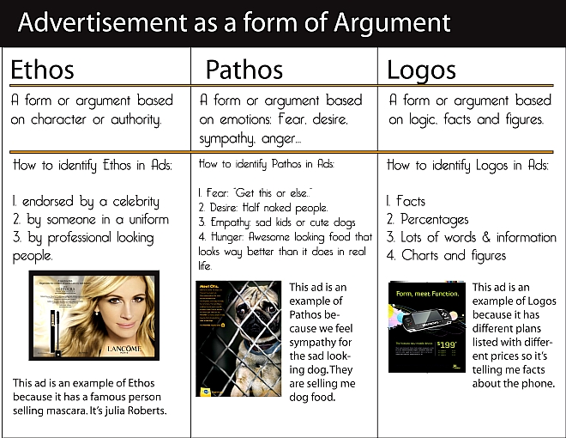
Basic Analysis of an Argument in a Visual Ad

Identify the following elements that amount to the argument the ad presents:

- What does the ad seem to be selling?

- What is the threat presented by this ad?

- How does it promise to rescue the viewer?

- Identify the main persuasive appeal that characterizes the ad and state how successful you feel it is in convincing an audience.

- Any evidence (objects, facts, caption, etc.) you can identify that leads you to that claim:

FINDING A THESIS for this ad:

1st The Topic:

2nd Position on topic:

3rd Main Reason:

Then write the claim/thesis as a sentence:

Any other observations about the obvious or subliminal “messages” of this ad, consider use of color, arrangement of elements, tone, etc.

What is the ad “really” selling in order to persuade…?

