Basic Analysis of an Argument in a Visual Ad
Please choose and print-out a visual internet advertisement. If the image is not a color printout, please access it on a full color screen to help complete this analytic exercise.
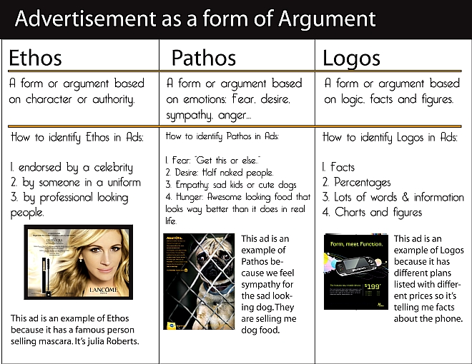

Identify the following elements that amount to the argument the ad presents:

- What does the ad seem to be selling?

- What is the threat presented by this ad?

- How does it promise to rescue the viewer?

- Identify the main persuasive appeal that characterizes the ad and state how successful you feel it is in convincing an audience.

- Identify and explain any evidence (objects, facts, caption, etc.) which leads you to that claim:

- Find/Make a thesis for this ad, as you perceive it:

- 1st The Topic:

- 2nd Position/perspective on topic:

- 3rd The Main Reason:

- Then write these elements of a claim/thesis as one sentence:

- Add any other observations about the obvious or subliminal “messages” of this ad, consider use of color, arrangement of elements, tone, etc.

- What (feeling, value, idea...) is the ad “really” using in order to persuade?

