Your Name
Instructor Name
Course Number
Assignment
Date

Title: Subtitle
Research papers that use MLA format do not include a cover page unless requested by your instructor. Instead, start with the information shown at the top of this page. Do not bold the title or use all capital letters. Capitalize the first and last words of the title, and all principal words. If your paper includes a subtitle, separate it from the title by a colon and space, as shown. For more specific guidance on capitalization, see the MLA Handbook for Writers of Research Papers, 7th Edition (MLA 7th Edition).
All text—including titles, quotations, notes, and list of works cited—uses double line spacing. Body text and note text use a half-inch first-line indent. The list of works cited uses a half-inch hanging indent. Table titles and source text use a quarter-inch indent. Access all of these text formats on the Home tab, in the Styles gallery.
MLA format discourages extensive use of content notes. But, when you need to add notes, you can use either endnotes or footnotes. MLA 7th Edition indicates that you should use a superscript, Arabic numeral at an appropriate place in the text for the note reference. To begin the note text, use the same numeral, not superscript, and followed by a period.
If you use endnotes, they should be on a separate page, at the end of your text and preceding the list of works cited. If you use footnotes, consult your professor for preferred format.
For quotations of more than four lines, indent the quote one inch from the left margin and do not use quotation marks. To apply this formatting, on the Home tab, in the Styles gallery, click Quote. For shorter quotations, you can put them in quotation marks and incorporate them directly into text.
Table 1
This Table Title Uses a Style Named “Table Title”, Available on the Home Tab, in the Styles Gallery
Column Heading | Additional  Column Heading | Additional  Column Heading | Additional  Column Heading
Row heading | Table text | Table text | Table text
Row heading | Table text | Table text | Table text
Row heading | Table text | Table text | Table text
Source: This source text uses a style named “Table Source”, available on the Home tab, in the Styles gallery.
- This note text uses a style named “Table Note”, available on the Home tab, in the Styles gallery. Table notes use a lowercase letter instead of Arabic numerals to differentiate them from the notes to body content.
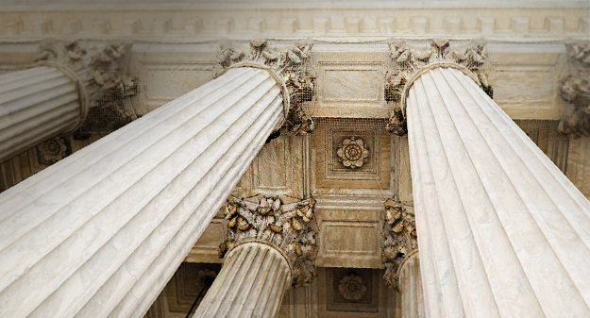
Fig. 1. This figure caption uses the No Indent style, available on the Home tab, in the Styles gallery. Label figures with the abbreviated “Fig.” and a figure number.
The sample Works Cited list that follows starts on its own page. Just type in-text citations as you do any text of your paper. See the sample citation shown at the end of this paragraph. Note also that MLA rules for citations and references are extensive. So it’s a good idea to refer to MLA 7th Edition for further information. (AuthorLastName Pages)
To see this document with all layout and formatting, such as hanging indents, on the View tab, click Reading View. To use this template when creating the outline for your paper, on the Home tab, in the Styles gallery, click No Indent.
For additional guidance on formatting your research paper, consult MLA 7th Edition as well as your instructor.

Works Cited
AuthorLastName, FirstName. Title of the Book Being Referenced. City Name: Name of Publisher, Year. Type of Medium (e.g., Print).
LastName, First, Middle. “Article Title.” Journal Title (Year): Pages From - To. Print.

